Eastfield Primary Academy
Margaret Street
Immingham
North East Lincolnshire
DN40 1LD

Tel 01469 572455

Principal – Kerry Thompson
Office – office@eastfieldprimary.co.uk

Thursday 20th December 2018
Dear Parents/Carers,

We have had an amazing autumn term and everyone has worked really hard! Both staff and children are looking forward to the Christmas break and a well deserved rest!

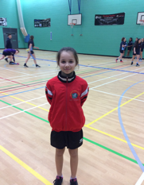 |  |  | Sports Hall Athletics  In the finals we finished overall in 7th position out of 28 schools. We did really well and are really proud of those children who took part.  How do you feel about representing the school at these competitions? I feel really good as it helps increase my confidence.  What did you enjoy the most about competing today? I really enjoyed the 2x1 relay because it was straight forward all I had to worry about is running fast and passing the baton to Rebekah.  What is your favourite thing about this sport? My favourite thing about Sports Hall Athletics is being in competition with other people and I really enjoy the Standing Triple Jump as I have practiced this a lot in PE and After-school club.
Dance
This half term Years 2, 3, 5 and 6 have had weekly dance sessions with a dance teacher, Mrs Fuller. They have really enjoyed themselves and learnt key dance skills. These sessions culminated in a performance to their parents.
Years 3 and 4
Years 3 and 4 went off to ‘Classroom in the Woods’ to experience living in the ‘Stone Age’. They really enjoyed themselves and learnt lots!
Louis said, he enjoyed trying the fish best because he’d never tried it like that before.
Ellie said, my favourite part of the trip was building the shelter because it took teamwork.

Years 5 & 6
Years 5 & 6 took part in helping to make the lanterns as part of the Mayflower400 Lantern Parade. They were really well behaved and learnt some new skills!
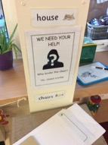 | 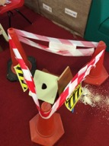 |  | Early Years  Children in EY have been reading the book, “Once Upon a Jolly Postman’. The children came to school dressed as their favourite story character and they had to find clues to solve a crime!  Both children and staff had a great time!
Wreaths  As part of our involvement with St.Andrew’s Church, every class made an advent wreath that has been hung in St.Andrew’s as part of their festive celebrations.We are proud to support our local community! Children also made wreaths for school that we hung in the Coffee Shop; they are beautiful! |  |  | 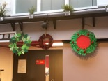 |  |  | 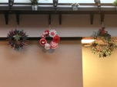
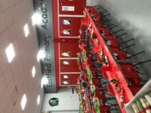 | 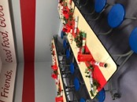 |  | Christmas Lunch  Christmas lunch was a huge success! Both children and staff ate together and the food was delicious – yum, yum! We set up tables in both the Dining Room and the Sports Hall to ensure we could get everyone in!
Christingle Service  This took place in school; every child made a Christingle and Rev Julie Donn led the Service. We raised £66 for the Children’s Society. |  |  | 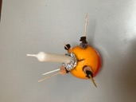 |  | 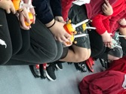
Years 5 & 6
Years 5 and 6 have been reading ‘Goodbye Mr Tom’ as part of their work in Literacy and History. The story is set during WWII and Mr Parson’s came in to talk to the children about WWII and what life was like.
The children really enjoyed his presentation; he brought lots of artefacts in for the children to look at and he knew lots of interesting facts about WWII!
‘Whoops-a-Daisy Angel!’
Early Years performed ‘Whoops-a-Daisy Angel and they were amazing! They knew their lines and all the words to the songs – they performed twice and both performances were brilliant! Well done EY!
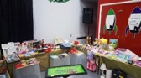 | 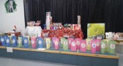 |  | Enterprise Day  Thank you to everyone who came and supported us – we raised over £1,400; our best total yet!
Samaritan’s Purse
We sent 30 shoeboxes off to the Samaritan’s Purse charity – thank you very much for your support! We will make 30 children very happy this Christmas!

Miracle in Town!’
Years 1 and 2 performed ‘Miracle in Town’ and proved themselves to be true performers! Not everything went according to plan, but the children were just fantastic and got on with the show! Well done KS1, we are super proud of you!
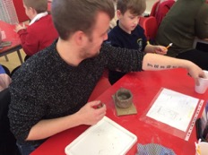 |  |  | Years 3 and 4  Years 3 and 4 have invited parents in to support with Art this term and making clay pots!  Jaiden said, doing the clay work was good. Decorating the pot was really hard but my dad helped me.
Magic Carpet: Mr Shell’s Seaside Spells’
The children enjoyed the performance again! It is always exciting to see a live theatre performance that is fun and engaging. We are already wondering what next year’s performance will be about???

We have had a very busy and exciting autumn term are looking forward to January 2019 and continuing our learning journey!

We are saying goodbye to Mrs Tennyson at the end of this term - she is retiring and taking a well-earned rest! We would like to take this opportunity to wish her a ‘happy retirement’ and thank her for all her hard work over the years!

Thank you for all of your support this term and we hope that you have a lovely Christmas and a Happy New Year!

